21.15: 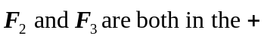x-direction.
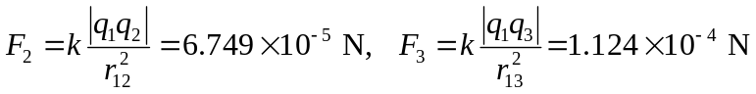
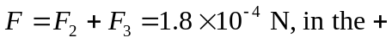x-direction.

